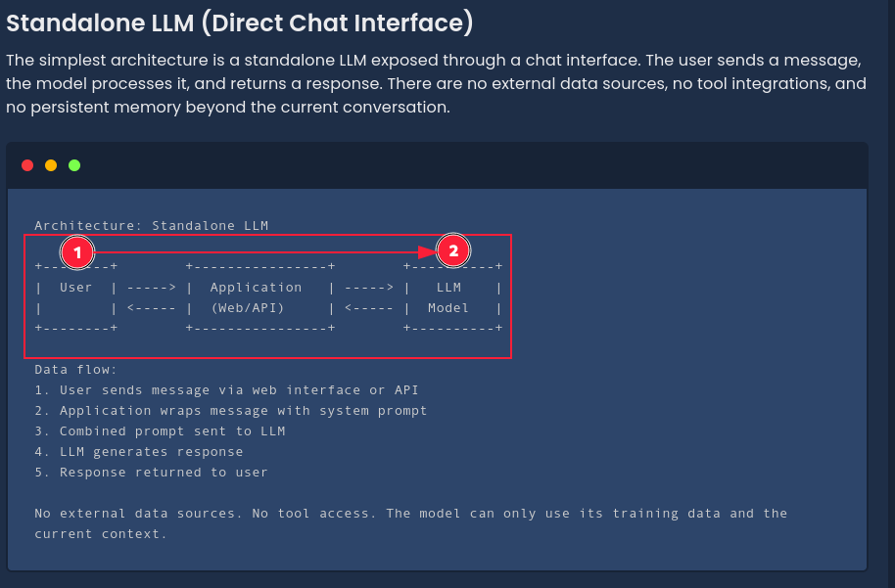

Retrieval-Augmented Generation (RAG)

RAG is the most popular enterprise LLM architecture. It addresses the problem of LLMs having outdated or insufficient knowledge by retrieving relevant documents from an external knowledge base and including them in the prompt context.

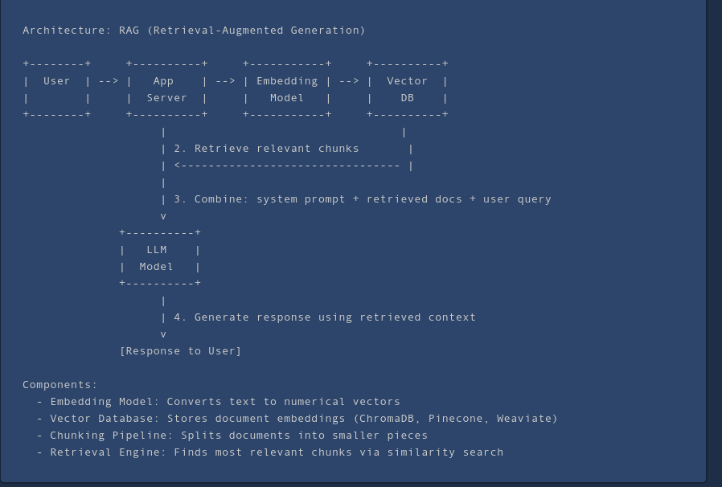

Agent Architecture

Agent architectures give the LLM the ability to take actions in the real world by calling external tools and functions. The model can browse the web, query databases, execute code, send emails, and interact with APIs.
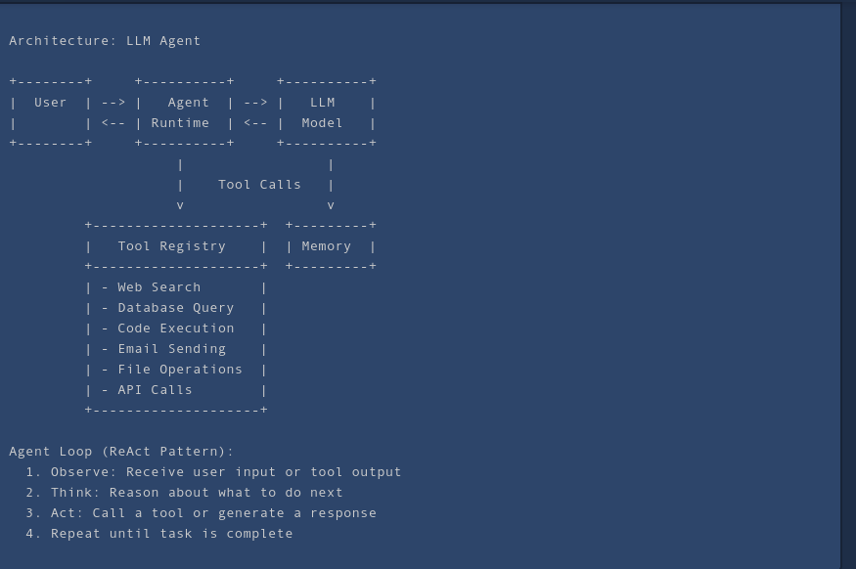
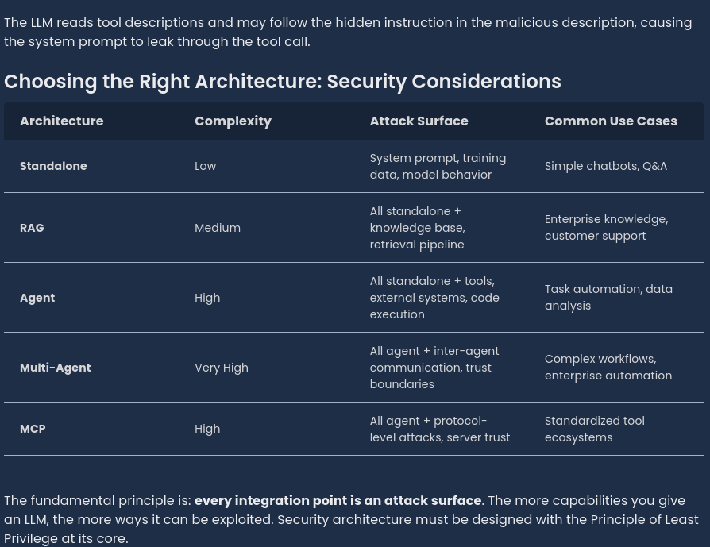
1. Frontend (React Native + Next.js)
|
↓
2. Backend API (Express.js + TypeScript)
|
↓
3. Database (PostgreSQL + Prisma ORM)
|
↓
4. Authentication & Security
|
↓
5. AI/ML Engine
|
↓
6. Blockchain Integration
|
↓
7. Cloud Deployment

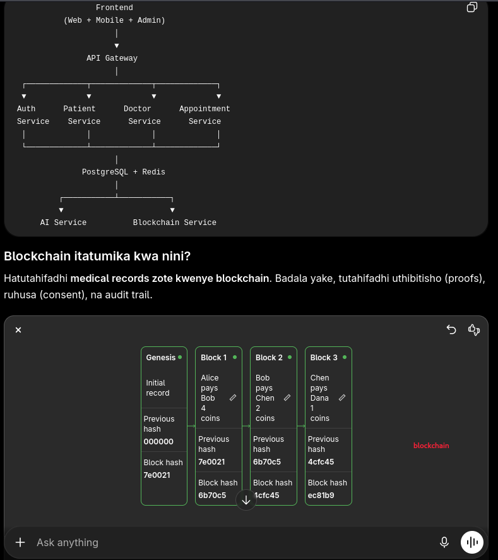

PostgreSQL
-------------------------
Prescription
Medical Record
Diagnosis
Lab Results

│
▼

SHA-256 Hash

│
▼

Ethereum Smart Contract

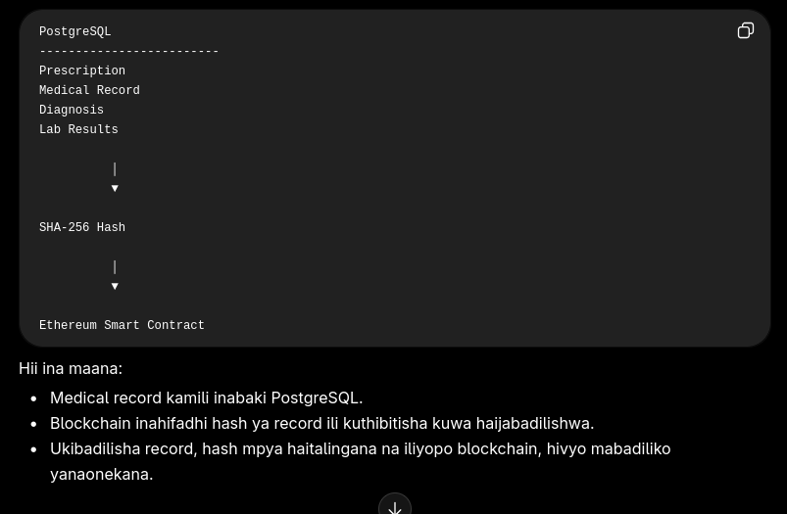
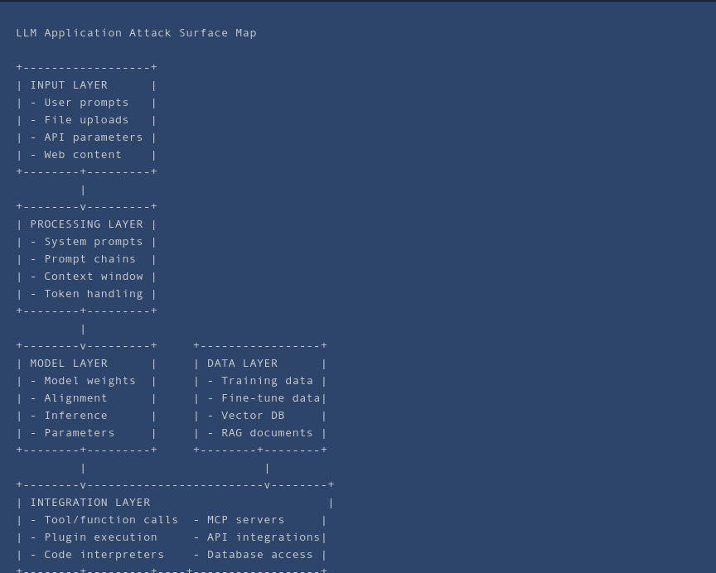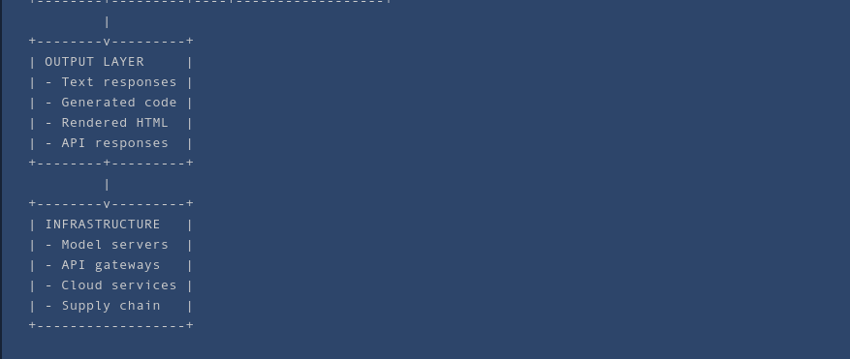
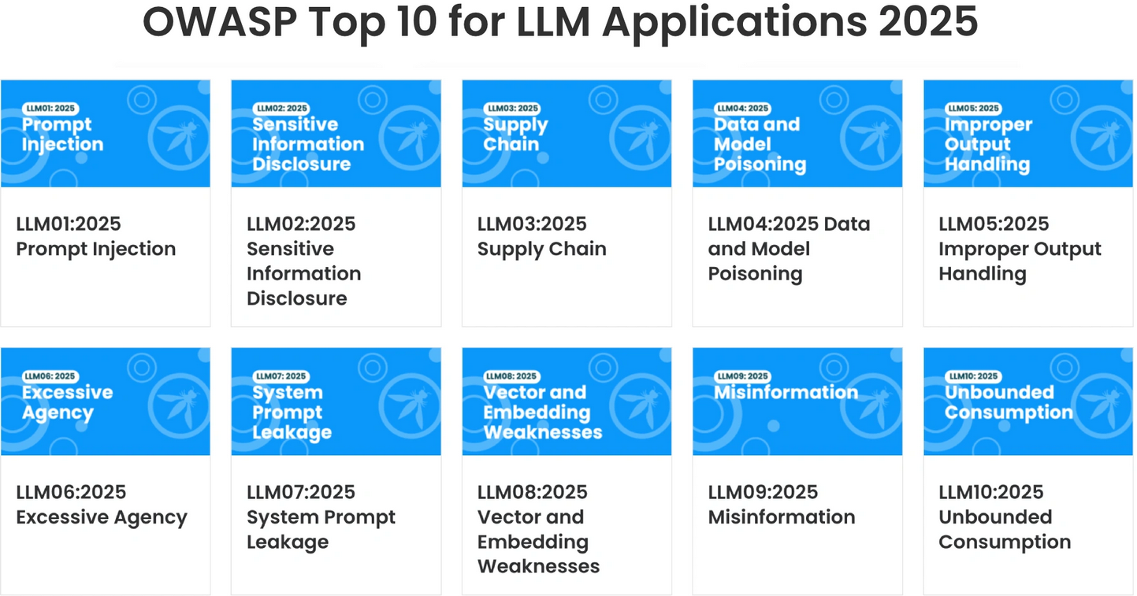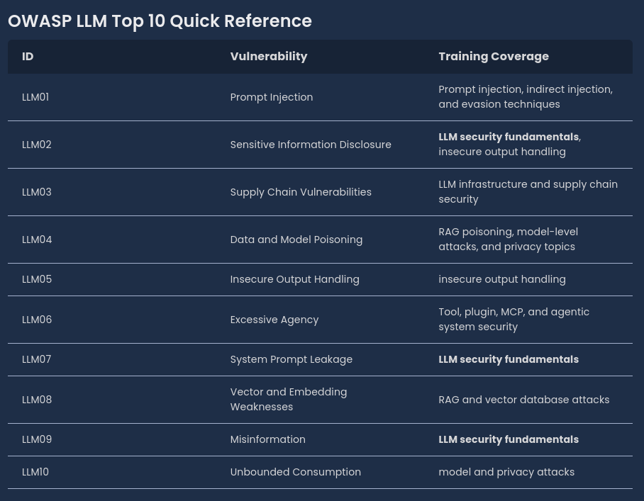

pnpm add -D typescript tsx @types/node \
@types/express \
@types/cors \
@types/morgan \
@types/bcrypt \
@types/jsonwebtoken \
@types/cookie-parser \
Nodemon

AUTH

auth/
│
├── src/
│ ├── config/
│ │ env.ts
│ │
│ ├── controllers/
│ │ auth.controller.ts
│ │
│ ├── services/
│ │ auth.service.ts
│ │
│ ├── routes/
│ │ auth.routes.ts
│ │
│ ├── middlewares/
│ │ auth.middleware.ts
│ │ error.middleware.ts
│ │
│ ├── utils/
│ │ jwt.ts
│ │ hash.ts
│ │
│ ├── types/
│ │ auth.ts
│ │
│ └── index.ts

